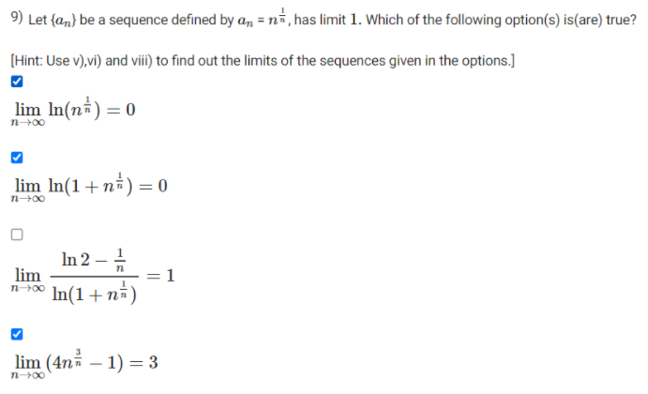

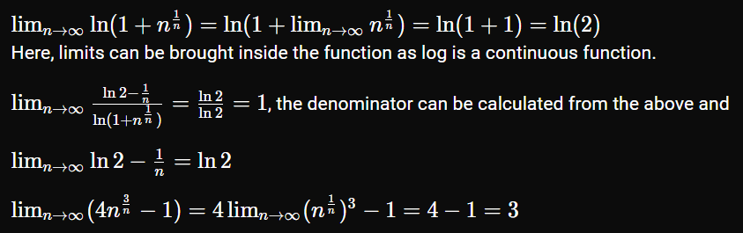

## Graded2





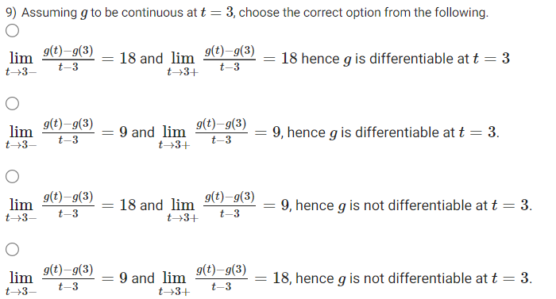

Doubt: Not sure how this expression evaluates differentiability.

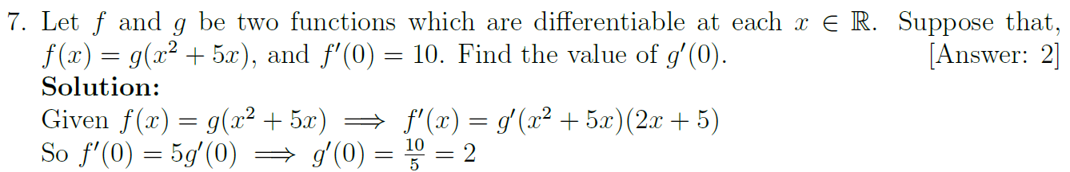

## AQ3.4







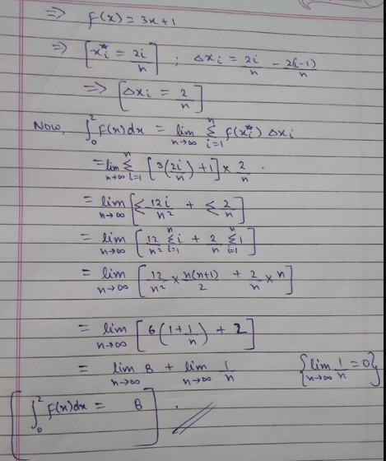

## Practice3



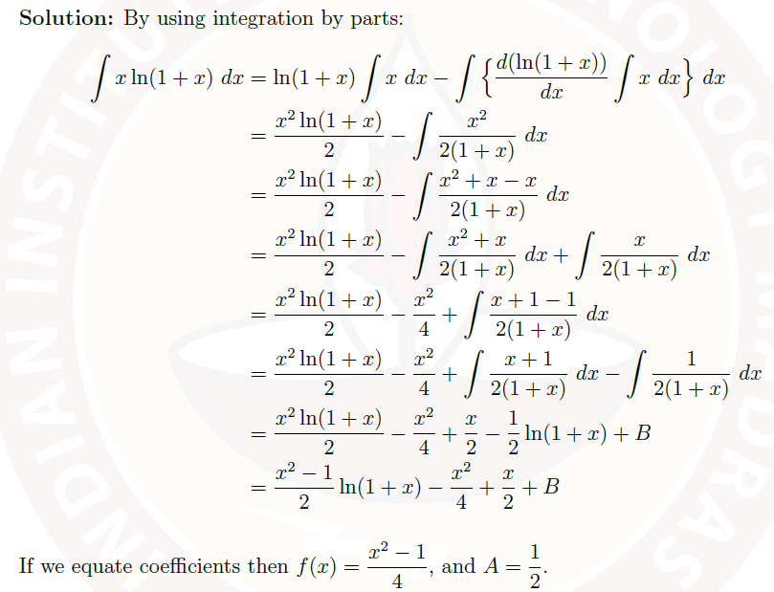

<https://www.youtube.com/watch?v=fTCDNe4GDHI>

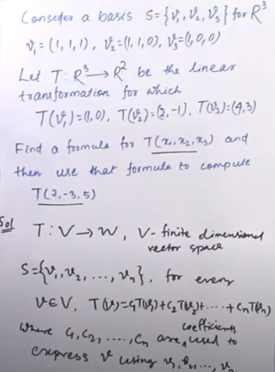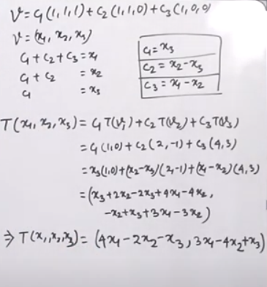

## AQ8.1

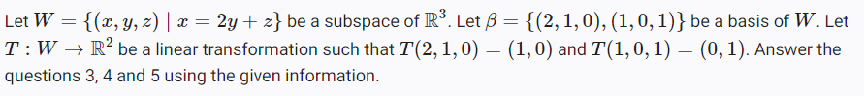



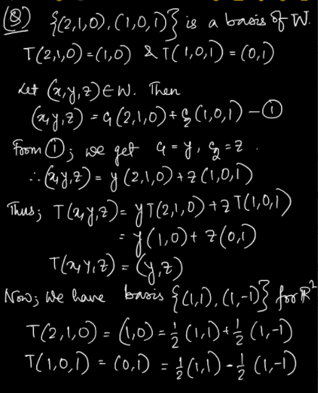

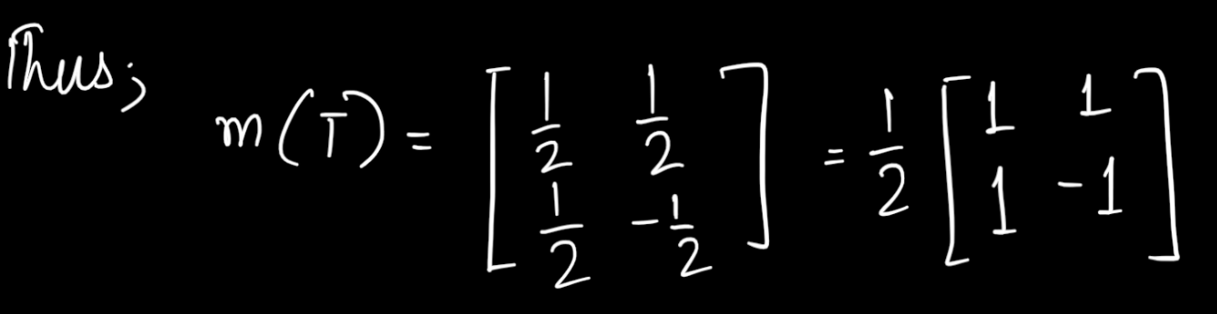

## Vector Calculus

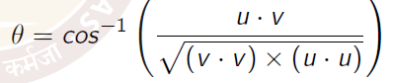

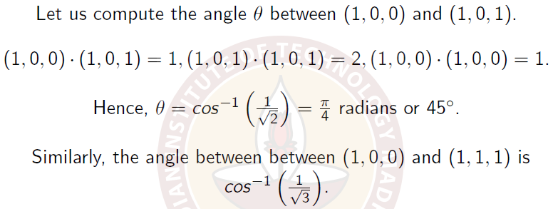

Representing vector as a linear combination

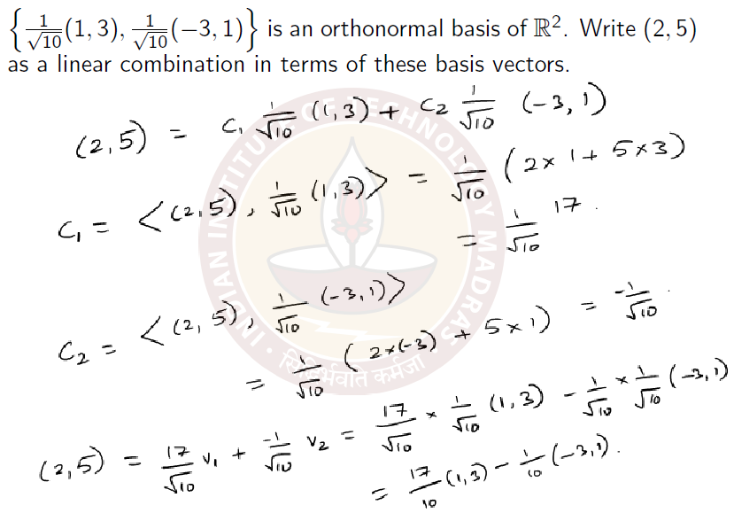

Finding the projection of a vector into a subspace

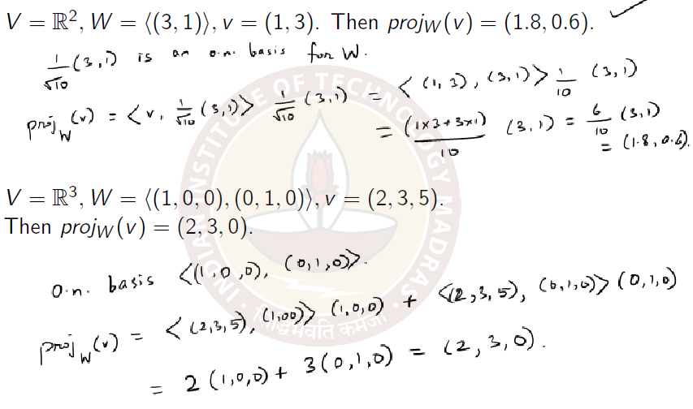

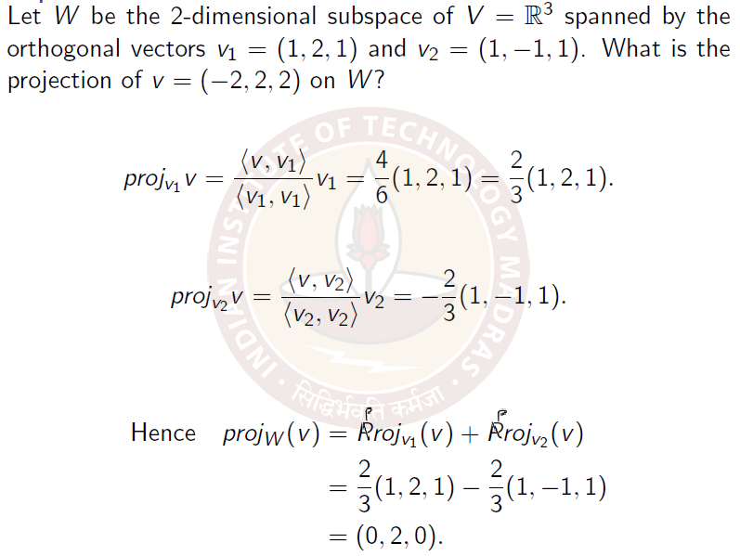

Practice10

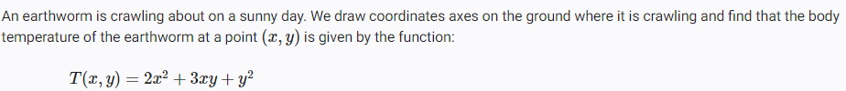

To arrive at the answer, take partial derivative of T(x, y) on x at (1,1), multiply with x component of the unit vector in direction (2,3); take partial derivative of T(x, y) on y at (1,1), multiply with y component of the unit vector in direction (2,3); add them together.

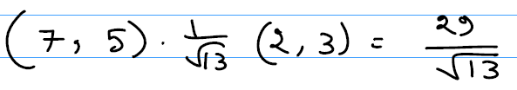

Thus,

